Nama : Fawaz Al Rasyid

NIM : 1301213016

CSLL.h

CSLL.cpp

Main.cpp

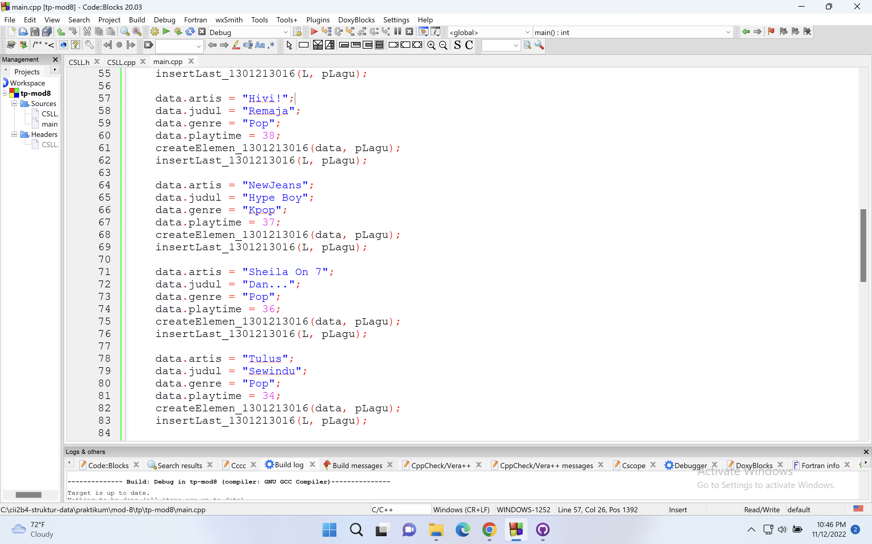

Output

